300960C
1999-2006 GM 1500
C-NOTCH FRAME SUPPORT
HARDWARE:
1/2-13 X 1 1/2 HEX BOLT (20) 1/2” FLAT WASHER (40) 3/8” FLAT WASHER (2)
1/2-13 NYLOCK NUT (20) 3/8-16 NYLOCK NUT (2) BUMP STOPS (2)
Note: It will be easier to find the exact point where the axle hits the frame if you install your lowering kit first.

- 1) Jack up the rear of the vehicle and support under the frame rails with jack stands. Allow the suspension to extend to full droop and remove the wheels.
- Place a floor jack under the rear diff and jack up the axle. With the axle now close to the frame, scribe a center mark of where the axle will contact the frame. (SEE IMAGE 1)
Note: This mark will be the center of your cut for the frame support.
- Mark the area that needs to be cut out. This can be achieved by:
- measuring the “C” area of the fame support and drawing that onto the frame with your center mark at the center of your cut out (IMAGE 2)
– by placing the frame support up to the frame and tracing the outer shape of the C
– or by making a template of the frame support and tracing that onto the frame.
- Cut out the scribed line using a plasma cutter or other suitable cutting device.
- With the cut-out section removed, test fit the frame support to ensure it sits up flush and proper to the frame. If it does not, then keep trimming until it does. Note: The bend on the frame support bends outward and toward the front of the truck.
- Remove the frame support, grind all cut edges smooth and spray paint for rust prevention.
- Clamp the frame support back into place. Using the holes in the support as a guide, drill out all mounting holes with a 1/2” drill bit.
- Install all side mounting hardware followed by the bottom hardware and tighten.
- Attach the low-profile bump stop to the frame support using the provided 3/8” hardware.
- Repeat steps 1-9 on the other side.

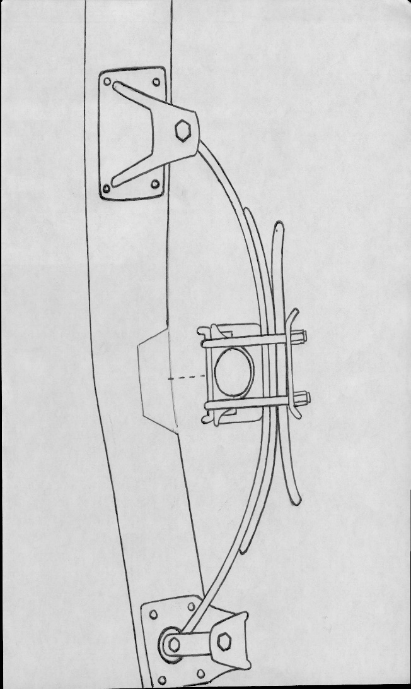
IMAGE 1

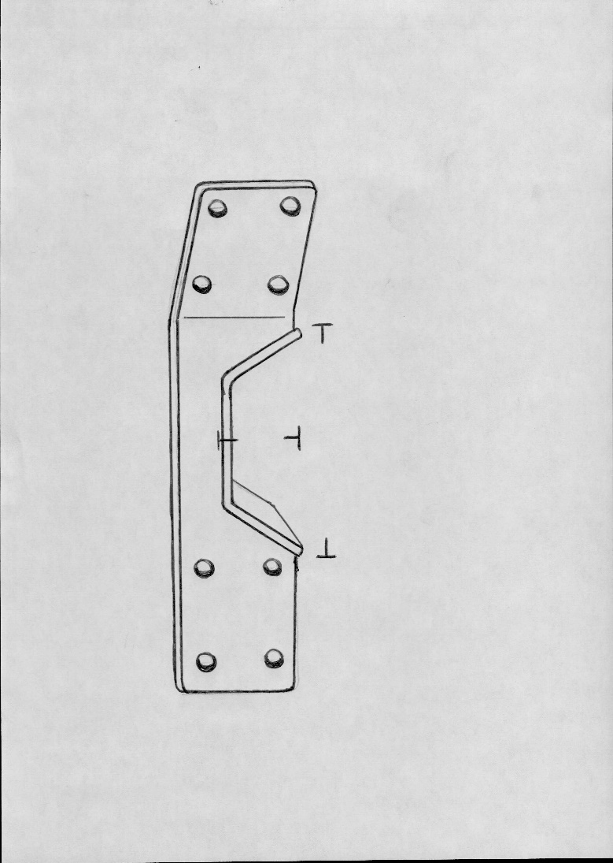
IMAGE 2

