613300
2017+ F-250/F-350 CARRIER BEARING KIT
FOR TRUCKS W/ A TWO PIECE DRIVE SHAFT
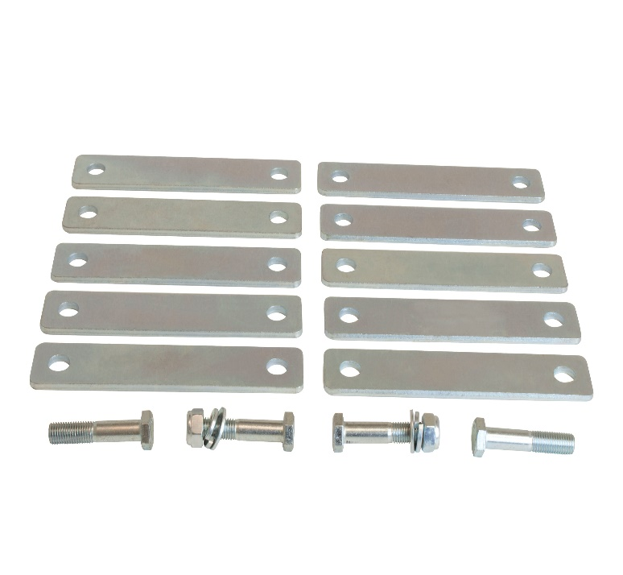
HARDWARE:
(10) SHIMS / (2) M12-1.75 X 65 / (2) M12-1.75 X 75 (2) M12 FW / (2) ½” SLW

- Park the truck on level ground and chock the wheels.
- Remove the two bolts holding the carrier bearing to the frame cross member. NOTE: SUPPORT THE DRIVE SHAFT WITH A STRAP. DO NOT ALLOW IT TO HANG UNSUPPORTED
- If installing with the a 4” lift, start with 4 shims. If installing with a 6” lift, start with 6 shims and use the length bolt that fits your quantity of shims best.
- Place the shims between the frame cross member and the carrier bearing and torque the supplied bolts to 30 ft/lbs.
- After driving the vehicle, adjustments can be made by adding or removing shims as needed. In some cases, not all vibrations can be eliminated due to the added leverage of large tires and the lift system.

